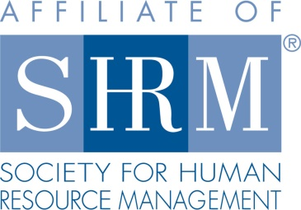

***Human Resource Law Update (1PDC)***

**Luncheon Seminar**

***Highland Rim SHRM*** is presenting a training session that will provide information on the most recent employment law matters.

Please join us for a lunch and learn training session presented by John R. LaBar, member of the Henry & McCord law firm located in Tullahoma, TN. Mr. LaBar will present information regarding the most recent employment law topics in both administrative matters as wells as in litigation, including matters in State and Federal courts, the EEOC, NLRB, and the Fair Labor Standards Act.

Mr. LaBar will provide updated employment law forms and compliance posters.

Human Resource professionals, business owners, managers and supervisors are welcome to attend.

***Tuesday, June 27th - 11:30 am-1:00 pm***

***Marcum Capital***

***410 Wilson Ave, Tullahoma***

***John R. LaBar, Attorney, Henry & McCord Attorneys at Law***

***RSVP by email to*** [***highlandrimshrm@gmail.com***](mailto:highlandrimshrm@gmail.com) ***by***

***Friday, June 23th, 2017. The cost of the seminar is free for members and $5.00 for lunch. The cost for nonmembers is $20 (includes lunch).***

