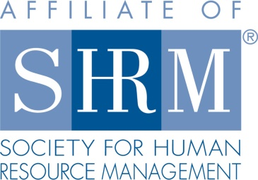

***2017 Employment Law Updates (3.5 PDC)***

**Seminar**

***Highland Rim SHRM*** is hosting a half day seminar on Employment Law updates. Topics will include:

* New I-9 Forms and the requirement
* Immigration issues for employers
* Marijuana use and what employers are doing to modify their policies
* Repeal of the ACA: what that means for employers and the impact of benefits in the workplace

Our presenters will be Attorney Charles Grant and Attorney Mabel Arroyo-Tirado shareholders with Baker Donelson Bearman Caldwell & Berkowitz, PC; Nashville, TN. Human Resource professionals, business owners, managers and supervisors are welcome to attend.

***Wednesday, March 15th***

***Motlow State Community College***

***Jack Daniel’s Meeting Room, Forrester Student Center***

***6015 Ledford Mill Road, Tullahoma, TN***

***Registration begins at 8:00 a.m.***

***Seminar is 8:30 a.m.-12:00 p.m.***

***Please see the link below for Forrester Student Center and parking location.***

[***http://www.mscc.edu/moore_county_campus_map.pdf***](http://www.mscc.edu/moore_county_campus_map.pdf)

***RSVP by email to*** [***highlandrimshrm@gmail.com***](mailto:highlandrimshrm@gmail.com) ***by Monday, March 13th, 2017. The cost of the seminar is $20 for members, and $75 for non-chapter members. Join the chapter or renew your membership at*** [***highlandrimshrm@gmail.com***](mailto:highlandrimshrm@gmail.com) ***before the conference and receive the discounted rate for this seminar, the fall seminar and chapter meetings. Continental breakfast will be served.***

