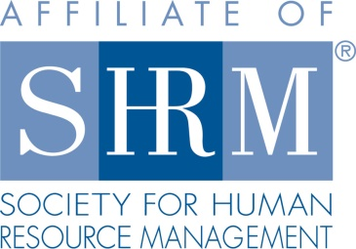

***Successful HR Strategies for Building an Ethical Workplace Culture (1PDC)***

**Luncheon Seminar**

***Highland Rim SHRM*** is presenting a webinar training session that will help you assess the degree to which your organization has an ethical culture and the steps needed to build a stronger culture that will contribute to your business success. We will look at the current status of workplace ethics, the reasons good ethics equal good business, the elements of an ethical workplace culture, HR strategies to build a stronger culture, and the importance of ethical practice as an HR competency.

Please join us for lunch and a webinar presented by Shelly Trent, Field Services Director for the SHRM. Human Resource professionals, business owners, managers and supervisors are welcome to attend.

***Thursday, January 26th - 11:30 am-1:00 pm***

***The Tullahoma Business Center***

***414 Wilson Ave, Tullahoma***

***Shelly Trent, Field Service Director, SHRM***

***RSVP by email to*** [***highlandrimshrm@gmail.com***](mailto:highlandrimshrm@gmail.com) ***by Tuesday, January 24th, 2017. The cost of the seminar is free for members and $5.00 for lunch. The cost for nonmembers is $20 (includes lunch).***

